ULTIMA 2.0
CS-435 Operating System
Phase 3—Memory Management

By:

Drake Wood
drawood@iu.edu

James Giegerich
jgiegeri@iu.edu

4/8/19

Table of Contents
Phase Abstract 2
Phase Description 3
Design Diagram 4
Source Code 5
Main.cpp 5
Semaphore.h 9
Semaphore.cpp 11
Window.h 13
Window.cpp 14
Queue.h 21
Queue.cpp 24
Scheduler.h 26
Scheduler.cpp 28
ipc.h 33
ipc.cpp 35
Memory.h 41
Memory.cpp 43
Makefile 51
Output 53

Phase Abstract
This report details the design and development of the third phase of the Ultima 2.0 project for C435. This program is written in C++ and is designed to run on a Unix operating system. This program and design are meant to be added to and upgraded in future iterations to add more features. This report includes the full source code as well as design diagrams.

Phase Description

This phase is to develop and implement a simulated a memory management system for the threads in our simulated operating system. One task must be able to write and read to memory according to a first-fit algorithm. Memory is a linked list of eight MemNode structs of 128 “bits” that add up to a total memory cap of 1024 “bits”. The mem_mgr class contains the MemNode struct, which includes type int data members base, limit, handle, linked and current_location, as well as a string type owner, two bool type status and start, and then a MemNode pointer next. Class mem_mgr methods include a constructor, a create_node(), MemAlloc(), Mem_Free(), Mem_Read() (including an overloaded version), Mem_Write() (including an overloaded version), First_Fit(), Mem_Left(), Mem_Smallest(), Mem_Coalesce(), Mem_Dump(), Core_Dump(), Mem_Usage(). Lastly, an array of char called Mem_Core[] is included to contain the actual contents of the memory space, whether written to, empty, or freed.
- Each time a thread is set to RUN, it writes a single random character to the first available memory block it finds, and that section of memory is “owned” by that thread so that other threads cannot write to it.
- Before the scheduler tells a thread to yield, it then reads the first character in the memory block that it owns.
- Once the character is read, it can be overwritten by the next Mem_write() call as long as that call is performed by the owning thread.
- Once a thread is killed, its memory is “freed” by replacing any characters within the block with # signs.
- Other methods are included to find the size of the smallest and largest blocks of free memory, as well as how much total memory is free in the whole system.

The text book Modern Operating Systems by Tanenbaum, C435 class notes, Unix manual, and some online research was used for external information.

Design Diagram
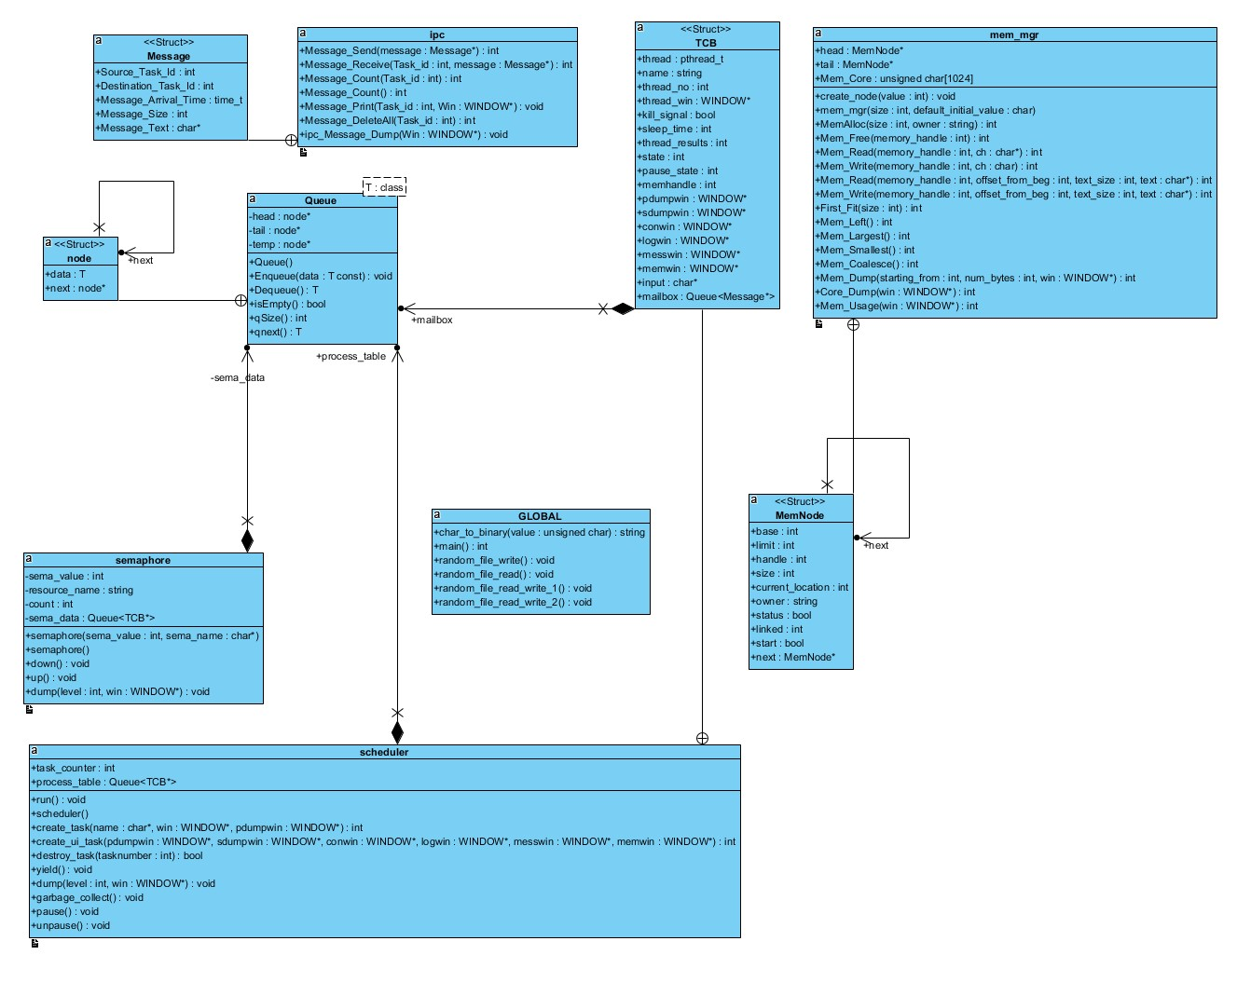

Source Code

Main.cpp
/*==================================================================================|
| Assignment: Ultima 2.0 Phase 3
| File Name: main.cpp
| Dependencies: scheduler.h semaphore.h window.h queue.h
| Authors: Drake Wood, James Giegerich
| Language: C++
| Compiler: G++
| Class: C435 - Operating Systems
| Instructor: Dr. Hakimzadeh
| Date Created: 2/16/2019
| Last Updated: 4/08/2019
| Due Date: 4/08/2019
|==================================================================================|
| Description: Contains the main function that interacts with the scheduler, semaphore, queue, and window classes.
| Multiple curses windows and 3 pthreads are created which are then passed to other functions to handle.
| The rest of main contains an input loop for the user to control what happens while the program is running.
| Details of the way functions are used and their parameters as well as
| computation details are given in the class descriptions.
*==================================================================================*/

#include <iostream>
#include <pthread.h> // Needed for using the pthread library
#include <assert.h>
#include <time.h>
#include <unistd.h> // Needed for sleep()
#include <ncurses.h> // Needed for Curses windowing
#include <stdarg.h> // Needed for formatted output to window
#include <termios.h>
#include <fcntl.h>
#include <cstdlib>
#include "queue.h"
#include "scheduler.h"
#include "semaphore.h"
#include "window.h"
#include "memory.h"

using namespace std;
semaphore sema_screen(1, (char *)"Screen Print"); // creates semaphores
semaphore sema_t1mail(1, (char *)"t1mail");
semaphore sema_t2mail(1, (char *)"t2mail");
semaphore sema_t3mail(1, (char *)"t3mail");
semaphore sema_t4mail(1, (char *)"t4mail");
semaphore sema_ptable(1, (char *)"ptable");
semaphore sema_memory(1, (char *)"memory");
scheduler sched; //creates scheduler
ipc IPC; // creates ipc
mem_mgr Mem_Mgr(1,1); // creates mem manager - size, initial value - dont do anything right now

//------------------------------------------------------------------------------
//------------------------------MAIN--------------------------------------------
//------------------------------------------------------------------------------

int main() {
initscr(); // Start nCurses
refresh(); // Refresh screen

//------------------------------------------------------------------------------
//Creating heading window, printing content
//------------------------------------------------------------------------------

WINDOW * Heading_Win = newwin(5, 80, 0, 2);
box(Heading_Win, 0,0);
mvwprintw(Heading_Win, 1, 26, "ULTIMA 2.0 Phase 3 (Spring 2019)");
mvwprintw(Heading_Win, 3, 28, "Drake Wood James Giegerich");
wrefresh(Heading_Win);

//------------------------------------------------------------------------------
//Creating log window
//------------------------------------------------------------------------------

WINDOW * Log_Win = create_window(15, 60, 20, 2);
write_window(Log_Win, 1, 18, "...........Log...........\n");

//------------------------------------------------------------------------------
//Creating console window
//------------------------------------------------------------------------------

WINDOW * Console_Win = create_window(15, 20, 20, 62);
write_window(Console_Win, 1, 1, " ....Console....\n");
write_window(Console_Win, 2, 1, "Ultima # ");
write_window(Log_Win, " Main program started\n" );

//------------------------------------------------------------------------------
//Creating 3 windows for tasks
//------------------------------------------------------------------------------

WINDOW * W1 = create_window(15, 25, 5, 2);
WINDOW * W2 = create_window(15, 25, 5, 30);
WINDOW * W3 = create_window(15, 25, 5, 57);

//------------------------------------------------------------------------------
//Creating a process table dump window
//------------------------------------------------------------------------------

WINDOW * Process_Table = create_window(9, 80, 0, 83);
write_window(Process_Table, 1, 5, " PROCESS TABLE DUMP \n -------------------------------------\n");

//------------------------------------------------------------------------------
//Creating tasks with create_task passing each a name and task window
//------------------------------------------------------------------------------

sched.create_task((char*)" Task 1", W1,Process_Table);
sched.create_task((char*)" Task 2", W2,Process_Table);
sched.create_task((char*)" Task 3", W3,Process_Table);

//-------------------------------------------------------------------------------
//Creating a semaphore dump window
//-------------------------------------------------------------------------------

WINDOW * Sema_Dump = create_window(16, 80, 9, 83);
write_window(Sema_Dump, 1, 5, " SEMAPHORE DUMP \n -------------------------------------\n");

//-------------------------------------------------------------------------------
//Creating a memory dump window
//-------------------------------------------------------------------------------

WINDOW * Mem_Dump = create_window(22, 80, 35, 2);
write_window(Mem_Dump, 1, 5, " MEMORY DUMP \n --------------------------------------------------------\n");

//------------------------------------------------------------------------------
//Create a Messaging dump window
//------------------------------------------------------------------------------

WINDOW * Message_Dump = create_window(17, 80, 25, 83);
write_window(Message_Dump, 1, 5, " MESSAGING DUMP \n -------------------------------------\n");

//------------------------------------------------------------------------------
//Setup for user console input
//------------------------------------------------------------------------------

cbreak(); // Set up keyboard I/O processing
noecho(); // disable line buffering
nodelay(Console_Win, true); // disable automatic echo of characters read by getch(), wgetch()
// nodelay causes getch to be a non-blocking call.
// If no input is ready, getch returns ERR

//------------------------------------------------------------------------------
//Start threads and run till end of program
//------------------------------------------------------------------------------

sched.run(); //start running all the tasks

sched.create_ui_task(Process_Table, Sema_Dump, Console_Win, Log_Win, Message_Dump, Mem_Dump);

while(sched.process_table.qSize() != 0){ // loop while threads run
sleep(1);
}

endwin();
return 0;
} // end of main

Semaphore.h
/*==================================================================================|
| Assignment: Ultima 2.0 Phase 3
| File Name: semaphore.h
| Dependencies: scheduler.h
| Authors: Drake Wood, James Giegerich
| Language: C++
| Compiler: G++
| Class: C435 - Operating Systems
| Instructor: Dr. Hakimzadeh
| Date Created: 2/16/2019
| Last Updated: 3/18/2019
| Due Date: 4/08/2019
|==================================================================================|
| Description: This is the header file which defines the class semaphore. There are 3 functions along with a
| constructor and deconstructor.
| -dump displays information related to this class in a window for debugging.
| -up creates a mutex and queues it, effectively locking a critical section.
| -down dequeues a mutex, unlocking it.
*==================================================================================*/

#ifndef SEMAPHORE_H
#define SEMAPHORE_H

#include <iostream>
#include <pthread.h> // Needed for using the pthread library
#include <assert.h>
#include <time.h>
#include <unistd.h> // Needed for sleep()
#include <ncurses.h> // Needed for Curses windowing
#include <stdarg.h> // Needed for formatted output to window
#include <termios.h>
#include <fcntl.h>
#include <cstdlib>
#include "queue.h"
#include "scheduler.h"
#include <string>

class semaphore {
int sema_value; // 0 or 1 in the case of a binary semaphore

Queue <scheduler::TCB*>sema_data;
std::string resource_name; // The name of the resource being managed
int count;

public:
semaphore(int sema_value, char* sema_name);
~semaphore();

void down(); // Get the resource or get queued!
void up(); // Release the resource
void dump(int level, WINDOW * win); // Include some
}; // Functions which will allow you to dump the
#endif // Contents of the semaphore in a readable format. See the expected
// Output section (below) for suggestions.

Semaphore.cpp
/*==================================================================================|
| Assignment: Ultima 2.0 Phase 3
| File Name: semaphore.cpp
| Dependencies: semaphore.h window.h
| Authors: Drake Wood, James Giegerich
| Language: C++
| Compiler: G++
| Class: C435 - Operating Systems
| Instructor: Dr. Hakimzadeh
| Date Created: 2/16/2019
| Last Updated: 4/08/2019
| Due Date: 4/08/2019
|==================================================================================|
| Description: Contains the definitions for the functions outlined in semaphore.h
*==================================================================================*/

#include "window.h"
#include "semaphore.h"
#include "scheduler.h"

extern semaphore sema_screen;
extern scheduler sched;
extern scheduler TCB;

void semaphore::down(){ // Lock resource

scheduler::TCB * tcb; // new tcb object

if (sema_value > 0){ // if no 1 else has access
sema_value--; // get access here
} else{ // if someone else has access then we need to queue and block ourselves
tcb = sched.process_table.Dequeue();
tcb->state = 0; // blocked
sched.process_table.Enqueue(tcb); //add back to process table
sema_data.Enqueue(tcb); // stick in sema queue waitlist

for (int i = 0; i < sched.process_table.qSize() -1 ; i++)
{
tcb = sched.process_table.Dequeue();
sched.process_table.Enqueue(tcb); //shuffle queue
}
}

} // end of down

void semaphore::up(){ // Release the resource

if (sema_data.isEmpty()){ // if no one is in line then set value back to 1
sema_value++;
} else {
scheduler::TCB * tcb = sema_data.Dequeue(); // get first in semaphore queue
scheduler::TCB * tcb2; // new tcb for comparison
for (int i = 0; i < sched.process_table.qSize() ; i++)
{
tcb2 = sched.process_table.Dequeue(); //get scheduler task
if (tcb->thread_no == tcb2->thread_no){ // if task id in scheduler matches the one in semaphore
tcb2->state = 1; //ready // change it to ready from blocked
}
sched.process_table.Enqueue(tcb2); //shuffle queue
}
}
} // end of up

void semaphore::dump(int level, WINDOW * win){
// giving semaphore a resource name

char buff[256];

sprintf(buff, " Resource: %s Sema Value: \t%d \n", resource_name.c_str(), sema_value); // Print the resource name of the current semaphore
write_window(win, buff);

std::string name;
if (sema_data.qSize() > 0){
scheduler::TCB * tcb;

for (int i = 0 ; sema_data.qSize(); i++){
tcb = sema_data.Dequeue();
name = tcb->name;
sema_data.Enqueue(tcb);
sprintf(buff, "%s -> ", name.c_str());
write_window(win, buff);
}
} else{
write_window(win, " \tSema Queue empty\n");
}
} // end of dump

semaphore::semaphore(int sema_value, char* sema_name){
count = 0;
this->sema_value = sema_value;
this->resource_name = sema_name;
}

semaphore::~semaphore(){
}

Window.h
/*==================================================================================|
| Assignment: Ultima 2.0 Phase 3
| File Name: window.h
| Dependencies: none
| Authors: Drake Wood, James Giegerich
| Language: C++
| Compiler: G++
| Class: C435 - Operating Systems
| Instructor: Dr. Hakimzadeh
| Date Created: 2/16/2019
| Last Updated: 3/18/2019
| Due Date: 4/08/2019
|==================================================================================|
| Description: This is the header file which defines the class window. There are 5 functions.
| -create_window draws a new window at a specified size and position, it also turns on scrolling.
| -write_window sends text to a specific window either with a position or without.
| -display_help prints a help window with console options for the user.
| -perform_simple_output is the function that the thread will run while alive, it prints an incrementing message.
*==================================================================================*/

#ifndef WINDOW_H
#define WINDOW_H

#include <iostream>
#include <pthread.h> // Needed for using the pthread library
#include <assert.h>
#include <time.h>
#include <unistd.h> // Needed for sleep()
#include <ncurses.h> // Needed for Curses windowing
#include <stdarg.h> // needed for formatted output to window
#include <termios.h>
#include <fcntl.h>
#include <cstdlib>

WINDOW *create_window(int height, int width, int starty, int startx);
void write_window(WINDOW * Win, const char* text);
void write_window(WINDOW * Win, int x, int y, const char* text);
void display_help(WINDOW * Win);
void *perform_simple_output(void *arguments);
void *ui_loop(void *arguments);

#endif

Window.cpp
/*==================================================================================|
| Assignment: Ultima 2.0 Phase 3
| File Name: window.cpp
| Dependencies: semaphore.h window.h
| Authors: Drake Wood, James Giegerich
| Language: C++
| Compiler: G++
| Class: C435 - Operating Systems
| Instructor: Dr. Hakimzadeh
| Date Created: 2/16/2019
| Last Updated: 4/08/2019
| Due Date: 4/08/2019
|==================================================================================|
| Description: Contains the definitions for the functions outlined in window.h
*==================================================================================*/

#include "window.h"
#include "semaphore.h"
#include "ipc.h"
#include "time.h"
#include "memory.h"
#include <cstring>

extern semaphore sema_screen;
extern semaphore sema_t1mail;
extern semaphore sema_t2mail;
extern semaphore sema_t3mail;
extern semaphore sema_t4mail;
extern semaphore sema_ptable;
extern scheduler sched;
extern ipc IPC;
extern mem_mgr Mem_Mgr;

WINDOW *create_window(int height, int width, int starty, int startx)
{
sema_screen.down();
WINDOW *Win;
Win = newwin(height, width, starty, startx);
scrollok(Win, TRUE); // Allow scrolling of the window
scroll(Win); // scroll the window
box(Win, 0 , 0); // 0, 0 gives default characters for the vertical and horizontal lines
wrefresh(Win); // draw the window
sema_screen.up();

return Win;
} // end of create_window

void write_window(WINDOW * Win, const char* text)
{
sema_screen.down();
wprintw(Win, text);
box(Win, 0 , 0);
wrefresh(Win); // Draw the window
sema_screen.up();
} // end of write_window

void write_window(WINDOW * Win, int y, int x, const char* text)
{
sema_screen.down();
mvwprintw(Win, y, x, text);
box(Win, 0 , 0);
wrefresh(Win); // Draw the window
sema_screen.up();
} // end of write_window

void display_help(WINDOW * Win)
{
sema_screen.down();
wclear(Win);
sema_screen.up(); // Write window already has its own lock
write_window(Win, 1, 1, "1: Kill Task 1");
write_window(Win, 2, 1, "2: Kill Task 2");
write_window(Win, 3, 1, "3: Kill Task 3");
write_window(Win, 4, 1, "c: Clear Screen");
write_window(Win, 5, 1, "d: Pause + Dump");
write_window(Win, 6, 1, "h: Help Screen");
write_window(Win, 7, 1, "q: Quit");
write_window(Win, 8, 1, "g: Garbage Collect");
write_window(Win, 9, 1, "z: Message testing");

} // end of display_help

void *perform_simple_output(void *arguments)
{
scheduler::TCB * tcb = (scheduler::TCB *) arguments; // Extract the thread arguments: (method 1)
int thread_no = tcb->thread_no; // Cast arguments in to thread_data
WINDOW * Win = tcb->thread_win;
WINDOW * pdumpwin = tcb->pdumpwin;
int CPU_Quantum =0;
int yield_quantum = 0;
char buff[256];
time_t messagetime;
char write;
char read = '=';
unsigned seed= time(0);
srand(seed);

while (tcb->state != 3){ // not dead
while(tcb->state == 2) { // running
if(yield_quantum == 0){ // updates process table when thread gets cpu time
//sched.dump(1, pdumpwin);
}

if (CPU_Quantum == 0) { // First thing a task does is send messages
for (int i = 1 ; i < 4; i++){
ipc::Message * message = new ipc::Message; // create message
message->Source_Task_Id = thread_no; // source = this task
message->Destination_Task_Id = i; // destination is every task
message->Message_Text = "message text"; // placeholder text
time(&messagetime); // get time
message->Message_Arrival_Time = messagetime; // store time
message->Message_Size = sizeof(message); // get and store size of message
if (IPC.Message_Send(message) == 1){ // send the message
sprintf(buff, " Message sent\n");
write_window(Win, buff);
}
}
}

if(tcb->kill_signal !=1){ //for some reason we cant die before printing or get corruption for now
sprintf(buff, " Task-%d running #%d\n", thread_no, CPU_Quantum++);
write_window(Win, buff);

//writes a random piece of data to memory at the beginning of yield cycle
if(yield_quantum == 1){
write = '0' + rand()%77;
Mem_Mgr.Mem_Write(tcb->memhandle,write); // write to memory once per yield cycle
}

}
yield_quantum++;
if (tcb->kill_signal == 1){ // set to be killed
write_window(Win, " I'm dying...\n");
tcb->state = 3;
sched.yield();
}
if (yield_quantum == 1001){// if quantum is up
yield_quantum = 0; //reset
// reads 1 ch of memory and prints at the end of yield cycle
if(Mem_Mgr.Mem_Read(tcb->memhandle,&read)){
sprintf(buff," Reading from memory... \n %c\n", read);
write_window(Win, buff);
}
write_window(Win, " I'm yielding...\n");
sched.yield();
//sleep(1);
}
}

} // end while
Mem_Mgr.Mem_Free(tcb->memhandle);
return 0;
}

void *ui_loop(void *arguments)
{
scheduler::TCB * tcb = (scheduler::TCB *) arguments; // Extract the thread arguments: (method 1)
// Cast arguments in to tcb
WINDOW * pdumpwin = tcb->pdumpwin;
WINDOW * sdumpwin = tcb->sdumpwin;
WINDOW * conwin = tcb->conwin;
WINDOW * logwin = tcb->logwin;
WINDOW * messwin = tcb->messwin;
WINDOW * memwin = tcb->memwin;
char* text= "This example shows the overloaded write/read function";
int textsize = strlen(text);
char* read = "reading didnt work";
char buff[256];

while (tcb->state != 3){ // not dead
while(tcb->state == 2) { // running
// updates process table when thread gets cpu time, removed for now
//sched.dump(1, pdumpwin);

switch(wgetch(conwin))
{
case '1':
write_window(conwin, "1 \n Ultima # ");
if (sched.destroy_task(1)){
write_window(logwin, " Task 1 killed. \n");
}else{
write_window(logwin, " Task 1 was already dead... \n ");
}
sched.yield();
break;
case '2':
write_window(conwin, "2 \n Ultima # ");
if (sched.destroy_task(2)){
write_window(logwin, " Task 2 killed. \n");
}else{
write_window(logwin, " Task 2 was already dead... \n ");
}
break;
case '3':
write_window(conwin, "3 \n Ultima # ");
if (sched.destroy_task(3)){
write_window(logwin, " Task 3 killed. \n");
}else{
write_window(logwin, " Task 3 was already dead... \n ");
}
break;
case 'c': // CLEAR and Coalesce

sema_screen.down();
refresh(); // Clear the entire screen (in case it is corrupted)
wclear(conwin); // Clear the Console window
sema_screen.up();

Mem_Mgr.Mem_Coalesce();

write_window(conwin, 1, 1, "Ultima # ");
break;
case 'd':
write_window(conwin, "d \n Ultima # ");
write_window(logwin, " Paused, press any key to continue... \n");
//sched.pause();
sched.dump(1, pdumpwin); // updates process dump windows

sema_screen.down();
refresh(); // Clear the entire screen (in case it is corrupted)
wclear(sdumpwin); // Clear the sema dump window
wclear(messwin); // Clear the message dump window
sema_screen.up();

write_window(sdumpwin, 1, 5, " SEMAPHORE DUMP \n -------------------------------------\n");
sema_screen.dump(1, sdumpwin);
sema_t1mail.dump(1, sdumpwin);
sema_t2mail.dump(1, sdumpwin);
sema_t3mail.dump(1, sdumpwin);
sema_t4mail.dump(1, sdumpwin);
sema_ptable.dump(1, sdumpwin);

//core dump
Mem_Mgr.Core_Dump(memwin);
sprintf(buff, " memory largest: %d smallest: %d left: %d \n", Mem_Mgr.Mem_Largest(), Mem_Mgr.Mem_Smallest(), Mem_Mgr.Mem_Left());
write_window(logwin, buff);

// overloaded read does not work
/*
if(Mem_Mgr.Mem_Read(tcb->memhandle,9, 20, &read)){
sprintf(buff," Reading from memory... \n %s\n", read);
write_window(logwin, buff);
}
*/

write_window(messwin, 1, 5, " MESSAGING DUMP \n -------------------------------------\n");
IPC.ipc_Message_Dump(messwin);
std::cin.get();
write_window(logwin, " Unpaused... \n");
break;
case 'h': // HELP and mem usage

display_help(conwin);

Mem_Mgr.Mem_Usage(memwin);

break;
case 'g':
sched.garbage_collect();
write_window(conwin, "g \n Ultima # ");
write_window(logwin, " Garbage collect\n");
//sched.yield();
break;
case 'q': // QUIT
write_window(logwin," Quiting the main program....\n" );
for (int i = 1; i < 4; i++){
if (sched.destroy_task(i)){ // Killed
sprintf(buff, " Task %d to be killed\n", i);
write_window(logwin, buff);
}else{ // Already dead
sprintf(buff, " Task %d already dead\n", i);
write_window(logwin, buff);
} // end else
} // end if
tcb->kill_signal = 1;
sched.yield();
break;
case 'z': // message test case
IPC.Message_Print(1, messwin); // print messages
sprintf(buff, " # of messages in task1 box = %d \n" , IPC.Message_Count(1));
write_window(messwin, buff);
sprintf(buff, " # of messages in all boxes = %d \n" , IPC.Message_Count());
write_window(messwin, buff);
sprintf(buff, " Deleting messages in task 1 box \n");
write_window(messwin, buff);
IPC.Message_DeleteAll(1);
sprintf(buff, " # of messages in task1 box = %d \n" , IPC.Message_Count(1));
write_window(messwin, buff);
sprintf(buff, " # of messages in all boxes = %d \n" , IPC.Message_Count());
write_window(messwin, buff);

Mem_Mgr.Mem_Write(tcb->memhandle, 9, textsize, text);

break;
case ERR: // If wgetch() return ERR, that means no keys were pressed
if (tcb->kill_signal == 1){ // set to be killed
write_window(logwin, " UI window dying...\n");
Mem_Mgr.Mem_Free(tcb->memhandle);
// free this memory if thread is dying
tcb->state = 3;
} else {
//write_window(logwin, " NO INPUT, UI yielding...\n");
sched.yield();
}

break;
default:
write_window(conwin, "\n -Invalid Command\n");
write_window(logwin, " -Invalid Command\n");
write_window(conwin, " Ultima # \n");

break;
} // end switch

if (tcb->state == 3){
write_window(logwin," Ultima 2.0 shutting down...\n" );
sched.garbage_collect();
}
} // while running

} // while not dead

return 0;

}

Queue.h
/*==================================================================================|
| Assignment: Ultima 2.0 Phase 3
| File Name: queue.h
| Dependencies: none
| Authors: Drake Wood, James Giegerich
| Language: C++
| Compiler: G++
| Class: C435 - Operating Systems
| Instructor: Dr. Hakimzadeh
| Date Created: 2/16/2019
| Last Updated: 3/18/2019
| Due Date: 4/08/2019
|==================================================================================|
| Description: This is the header file which defines the queue template class used by the semaphore
| and scheduler classes.
*==================================================================================*/

#ifndef QUEUE_H
#define QUEUE_H

#include <iostream>
#include <pthread.h> // Needed for using the pthread library
#include <assert.h>
#include <time.h>
#include <unistd.h> // Needed for sleep()
#include <ncurses.h> // Needed for Curses windowing
#include <stdarg.h> // needed for formatted output to window
#include <termios.h>
#include <fcntl.h>
#include <cstdlib>

template <class T>
class Queue{
private:
struct node{
T data;
node* next;
};
node* head;
node* tail;
node* temp;

public:
Queue();
void Enqueue(const T data);
T Dequeue();
bool isEmpty();
int qSize();
T qnext();
};

// Constructor.
template <class T>
Queue<T>::Queue(){
head = NULL;
tail = NULL;
temp = NULL;
}

template <class T>
int Queue<T>::qSize(){
int count = 0;
temp = head;

if (isEmpty()){
return count;
} // end if
else if (temp->next == NULL){
count++;
return count;
} // end if
else{
while (temp != NULL){
count++;
temp = temp->next;
} // end while

return count;
} // end else
} // end of qSize

//get data of next item, will probably be able to use this in yield
//so that we can pass the cpu to the next ID in the QUIT
//also in semaphore dump to show the Q there
template <class T>
T Queue<T>::qnext(){
T returnData;
returnData = head->next->data;
return returnData;
}

// Enqueues new node and populates the data
// with T data as passed in.
template <class T>
void Queue<T>::Enqueue(const T data){
if (tail == NULL){
head = tail = new node;
tail->next = NULL;
tail->data = data;
} // end if
else {
tail->next = new node;
tail->next->data = data;
tail->next->next = NULL;
tail = tail->next;
} // end else
} // end of Enqueue

// Dequeues node and returns data stored
// in dequeued node.
template <class T>
T Queue<T>::Dequeue(){
T returnData;
returnData = head->data;
temp = head->next;
delete head;
head = temp;
tail = (!head? NULL: tail);
return returnData;
}

// Checks if the queue is empty.
template <class T>
bool Queue<T>::isEmpty(){
return (!tail);
}

#endif

Queue.cpp
/*==================================================================================|
| Assignment: Ultima 2.0 Phase 3
| File Name: queue.cpp
| Dependencies: queue.h
| Authors: Drake Wood, James Giegerich
| Language: C++
| Compiler: G++
| Class: C435 - Operating Systems
| Instructor: Dr. Hakimzadeh
| Date Created: 2/16/2019
| Last Updated: 3/18/2019
| Due Date: 4/08/2019
|==================================================================================|
| Description: Contains the definitions for the functions outlined in queue.h
*==================================================================================*/

#include "queue.h"

// Constructor
template <class T>
Queue<T>::Queue(){
head = NULL;
tail = NULL;
temp = NULL;
}

template <class T>
int Queue<T>::qSize(){
int count = 0;
temp = head;

if (isEmpty()){
return count;
} // end if
else if (temp->next == NULL){
count++;
return count;
} // end if
else{
while (temp != NULL){
count++;
temp = temp->next;
} // end while
return count;
} // end else
} // end of qSize

// Enqueues new node and populates the data
// with T data as passed in.
template <class T>
void Queue<T>::Enqueue(const T data){
if (tail == NULL){
head = tail = new node;
tail->next = NULL;
tail->data = data;
} // end if
else {
tail->next = new node;
tail->next->data = data;
tail->next->next = NULL;
tail = tail->next;
} // end else
} // end Enqueue

// Dequeues node and returns data stored
// in dequeued node.
template <class T>
T Queue<T>::Dequeue(){
T returnData;
returnData = head->data;
temp = head->next;
delete head;
head = temp;
tail = (!head? NULL: tail);
return returnData;
}

// Checks if the queue is empty.
template <class T>
bool Queue<T>::isEmpty(){
return (!tail);
}

Scheduler.h
/*==================================================================================|
| Assignment: Ultima 2.0 Phase 3
| File Name: scheduler.h
| Dependencies: queue.h
| Authors: Drake Wood, James Giegerich
| Language: C++
| Compiler: G++
| Class: C435 - Operating Systems
| Instructor: Dr. Hakimzadeh
| Date Created: 2/16/2019
| Last Updated: 3/18/2019
| Due Date: 4/08/2019
|==================================================================================|
| Description: This is the header file which defines the class scheduler. There are 4 functions along with a
| constructor, deconstructor, and data structs.
| -dump displays information related to this class in a window for debugging.
| -garbage_collect finds threads that have been killed adn removes them from the process table.
| -create_task creates a new thread running simple output, its information is added to the process table.
| -destroy_task finds the task that the user wishes to kill and changes it status, stopping it.
| -TCB is the struct containing the thread_data which is stored in the process queue.
*==================================================================================*/

#ifndef SCHEDULER_H
#define SCHEDULER_H

#include <iostream>
#include <pthread.h> // Needed for using the pthread library
#include <assert.h>
#include <time.h>
#include <unistd.h> // Needed for sleep()
#include <ncurses.h> // Needed for Curses windowing
#include <stdarg.h> // Needed for formatted output to window
#include <termios.h>
#include <fcntl.h>
#include <cstdlib>
#include "queue.h"
#include <string>
#include "ipc.h"

class scheduler {
public:
struct TCB {
pthread_t thread;
std::string name;
int thread_no; // Thread number
WINDOW *thread_win; // Thread's window
bool kill_signal; // Kill signal flag live/kill
int sleep_time; // Sleep time
int thread_results; // Results
int state;
int pause_state;
int memhandle; // Memory handle
Queue<ipc::Message*> mailbox;
WINDOW *pdumpwin; // these are for the main input
WINDOW *sdumpwin;
WINDOW *conwin;
WINDOW *logwin;
WINDOW *messwin;
WINDOW *memwin;
char *input;
};

void run();
scheduler();
int task_counter;
Queue <TCB*>process_table;
int create_task(char* name, WINDOW *win, WINDOW *pdumpwin); // Create appropriate data structures and calls coroutine()
int create_ui_task(WINDOW *pdumpwin, WINDOW *sdumpwin, WINDOW *conwin, WINDOW *logwin, WINDOW * messwin, WINDOW * memwin);
bool destroy_task(int tasknumber); // to kill a task (Set its status to DEAD)
void yield(); // Strict round robin process switch.
void dump(int level, WINDOW * win); // Debugging function with level indicating the verbosity of the dump
void garbage_collect(); // Include some functions which will allow you to dump the contents of the
void pause();
void unpause();
}; // process table in a readable format. See the expected output section
#endif // (below) for suggestions.
// remove dead task, free their resources, etc.

Scheduler.cpp
/*==================================================================================|
| Assignment: Ultima 2.0 Phase 3
| File Name: scheduler.cpp
| Dependencies: scheduler.h semaphore.h window.h
| Authors: Drake Wood, James Giegerich
| Language: C++
| Compiler: G++
| Class: C435 - Operating Systems
| Instructor: Dr. Hakimzadeh
| Date Created: 2/16/2019
| Last Updated: 4/08/2019
| Due Date: 4/08/2019
|==================================================================================|
| Description: Contains the definitions for the functions outlined in scheduler.h
*==================================================================================*/

#include "semaphore.h"
#include "scheduler.h"
#include "window.h"
#include "memory.h"

#define BLOCKED 0
#define READY 1
#define RUNNING 2
#define DEAD 3

extern mem_mgr Mem_Mgr;
extern semaphore sema_screen;
extern semaphore sema_ptable;

void scheduler::dump(int level, WINDOW * win) {
sema_screen.down();
wclear(win);
sema_screen.up();
write_window(win, 1, 5, " PROCESS TABLE DUMP \n -------------------------------------\n");
char buff[256];
int procnum1;
int memhandle;
int size = process_table.qSize();

if (size == 0) // Check if anything is in the queue
write_window(win, " No tasks currently running...\n");
sema_ptable.down();
for(int i = 0 ; i < size ; i++){ // Search for a dead task
TCB *tcb = process_table.Dequeue();
process_table.Enqueue(tcb);
procnum1 = tcb->thread_no;
memhandle = tcb->memhandle;

if ( tcb->state == READY){
sprintf(buff, " Task #%d status: Ready\t\tMemory Handle: %d\n", procnum1, memhandle);
}
else if (tcb->state == RUNNING){
sprintf(buff, " Task #%d status: Running\tMemory Handle: %d\n", procnum1, memhandle);
}
else if (tcb->state == BLOCKED){
sprintf(buff, " Task #%d status: Blocked\t\tMemory Handle: %d\n", procnum1, memhandle);
}
else if (tcb->state == DEAD){
sprintf(buff, " Task #%d status: Dead\t\tMemory Handle: %d\n", procnum1, memhandle);
}// end else
write_window(win, buff);
} // end for
sema_ptable.up();
write_window(win, " -------------------------------------\n");
}// end of dump

void scheduler::garbage_collect() { // Delete those with dead status
sema_ptable.down();
int size = process_table.qSize();
for(int i = 0 ; i < size ; i++){
TCB *tcb = process_table.Dequeue();
if (tcb->state != DEAD){
process_table.Enqueue(tcb);
} // end if
} // end for
sema_ptable.up();
} // end of garbage_collect

int scheduler::create_task(char* name, WINDOW *win, WINDOW *pdumpwin){
int result_code;
TCB * tcb = new TCB;
this->task_counter++;
tcb->thread_win = win;
tcb->pdumpwin = pdumpwin;
write_window(tcb->thread_win, 13, 1, "Starting Thread.....\n");
tcb->thread_no = this->task_counter;
tcb->name = name;
tcb->state = READY;

tcb->memhandle = Mem_Mgr.MemAlloc(128, tcb->name);
if (tcb->memhandle == -1){
tcb->state = BLOCKED; // block if mem alloc fails
//will cause seg fault
}

// create thread running simple output in its own window
result_code = pthread_create(&tcb->thread, NULL, perform_simple_output, tcb);
assert(!result_code); // if there is any problems with result code. display it and end program.
sema_ptable.down();
process_table.Enqueue(tcb); // add to process table
sema_ptable.up();
return 0;
} // end of create_task

int scheduler::create_ui_task(WINDOW *pdumpwin, WINDOW *sdumpwin, WINDOW *conwin, WINDOW *logwin, WINDOW * messwin, WINDOW * memwin){
int result_code;
TCB * tcb = new TCB;
this->task_counter++;
tcb->pdumpwin = pdumpwin;
tcb->sdumpwin = sdumpwin;
tcb->conwin = conwin;
tcb->logwin = logwin;
tcb->messwin = messwin;
tcb->memwin = memwin;

tcb->thread_no = this->task_counter;
tcb->name = (char*) "UI Thread";
tcb->state = READY;

// get memory
char buff[256];
tcb->memhandle = Mem_Mgr.MemAlloc(128, tcb->name); // ask for 128 bits
if (tcb->memhandle == -1){
tcb->state = BLOCKED; // block if mem alloc fails
// will cause seg fault
}

// create thread ui loop
result_code = pthread_create(&tcb->thread, NULL, ui_loop, tcb);
assert(!result_code); // if there is any problems with result code. display it and end program.
sema_ptable.down();
process_table.Enqueue(tcb); // add to process table
sema_ptable.up();
return 0;
}
scheduler::scheduler(){
task_counter = 0;
}

bool scheduler::destroy_task(int tasknumber) {
bool flag = false;
sema_ptable.down();
for( int i =0; i < process_table.qSize(); i++){
if (!process_table.isEmpty()){ // this block searches Q for a specific process
TCB *tcb = process_table.Dequeue();
process_table.Enqueue(tcb); // if it is found kill signal is changed

if (tcb->thread_no == tasknumber){
if (tcb->kill_signal == 0){ // other processes are added back to Q
tcb->kill_signal = 1;
flag = true;
}else { //already killed.
//return 0;
} // end else
} // end if
} // end if
} // end for
sema_ptable.up();
return flag;
} // end of destroy_task

void scheduler::yield() { // Give scheduler the option to change state to ready or to continue running
sema_ptable.down();
// Change current thread state to READY.
TCB * tcb = process_table.Dequeue();
if (tcb->state != DEAD){ //dont ready if yielding after death
tcb->state = READY;
}
process_table.Enqueue(tcb);

// Find a thread that is READY.
tcb = process_table.Dequeue();
while (tcb->state != READY){ // might get stuck here?
process_table.Enqueue(tcb);
tcb = process_table.Dequeue();
}

tcb->state = RUNNING;
process_table.Enqueue(tcb);

// Shuffle the queue to put runnning thread back at front of queue.
for (int i = 0; i < (process_table.qSize() - 1); i++){
tcb = process_table.Dequeue();
process_table.Enqueue(tcb);
}
sema_ptable.up();
}

void scheduler::run(){
sema_ptable.down();
TCB *tcb = process_table.Dequeue();
tcb->state = RUNNING;
process_table.Enqueue(tcb);

// Shuffle the queue to put runnning thread back at front of queue.
for (int i = 0; i < (process_table.qSize() - 1); i++){
tcb = process_table.Dequeue();
process_table.Enqueue(tcb);
}
sema_ptable.up();
}

void scheduler::pause(){
sema_ptable.down();
for (int i = 0; i < (process_table.qSize()); i++){
TCB * tcb = process_table.Dequeue();
tcb->pause_state = tcb->state;
tcb->state = BLOCKED;
process_table.Enqueue(tcb);
}
sema_ptable.up();
}

void scheduler::unpause(){
sema_ptable.down();
for (int i = 0; i < (process_table.qSize()); i++){
TCB * tcb = process_table.Dequeue();
if (tcb->state != DEAD){
tcb->state = tcb->pause_state;
}

process_table.Enqueue(tcb);
}
sema_ptable.up();

ipc.h
/*==================================================================================|
| Assignment: Ultima 2.0 Phase 3
| File Name: ipc.h
| Dependencies: none
| Authors: Drake Wood, James Giegerich
| Language: C++
| Compiler: G++
| Class: C435 - Operating Systems
| Instructor: Dr. Hakimzadeh
| Date Created: 3/3/2019
| Last Updated: 3/18/2019
| Due Date: 4/08/2019
|==================================================================================|
| Description: This is the header file which defines the class ipc.
| This class contains 7 funtions and a message structure.
| -Message_Send takes a message as parameter and delivers it to destination.
| -Message_Receive reads first message in mailbox for given task.
| -Message_Count (single) returns the number of messages for given task.
| -Message_Count (all) returns total number of messages in all mailboxes.
| -Message_Print prints all messages for given task.
| -Message_DeleteAll delets all messages for given task.
| -ipc_Message_Dump prints all messages for all mailboxes.
*==================================================================================*/

#ifndef IPC_H
#define IPC_H

class ipc {
public:
struct Message {
int Source_Task_Id;
int Destination_Task_Id;
time_t Message_Arrival_Time; // research time.h, time_t, and tm
int Message_Size;
char *Message_Text;
//etc.
} ;
int Message_Send(Message *message); // returns -1 if error occurred. Return 1 if successful.
int Message_Receive(int Task_id, Message *message); // returns 0 if no more messages are available, loads the Message structure with
// the first message from the mailbox and remove the message from the mailbox.
// Return -1 if an error occurs.
int Message_Count(int Task_id); // return the number of messages in Task-idÃ¢â‚¬â„¢s message queue.
int Message_Count(); // return the total number of messages in all the message queues.
void Message_Print(int Task_id, WINDOW * Win); // print the all messages for a given Task-id.
int Message_DeleteAll(int Task_id); // delete all the messages for Task_id
void ipc_Message_Dump(WINDOW * Win); // print all the messages in the message queue, but do not delete them from the queue.
// (note that this function may be best placed in the scheduler!)
};
#endif

ipc.cpp
/*==================================================================================|
| Assignment: Ultima 2.0 Phase 3
| File Name: ipc.cpp
| Dependencies: ipc.h window.h queue.h scheduler.h semaphore.h
| Authors: Drake Wood, James Giegerich
| Language: C++
| Compiler: G++
| Class: C435 - Operating Systems
| Instructor: Dr. Hakimzadeh
| Date Created: 3/3/2019
| Last Updated: 3/18/2019
| Due Date: 4/08/2019
|==================================================================================|
| Description: Contains the definitions for the functions outlined in ipc.h
*==================================================================================*/

#include "window.h"
#include "queue.h"
#include "scheduler.h"
#include "ipc.h"
#include "semaphore.h"

extern semaphore sema_screen;
extern semaphore sema_t1mail;
extern semaphore sema_t2mail;
extern semaphore sema_t3mail;
extern semaphore sema_t4mail;
extern semaphore sema_ptable;
extern scheduler sched;
extern scheduler TCB;

// Sends message using destination in the message which is passed
int ipc::Message_Send( Message *message){ // returns -1 if error occurred. Return 1 if successful.
sema_ptable.down();
int flag = -1;
int dtID = message->Destination_Task_Id; // gets destination task
scheduler::TCB * tcb;

switch(dtID) // switch for using correct semaphore
{
case '1':
sema_t1mail.down();
break;
case '2':
sema_t2mail.down();
break;
case '3':
sema_t3mail.down();
break;
case '4':
sema_t4mail.down();
break;
}

for (int i = 0; i < sched.process_table.qSize(); i++){ // searches process table for the destination task
tcb = sched.process_table.Dequeue();
if (dtID == tcb->thread_no){

tcb->mailbox.Enqueue(message); // enqueues the message in the tasks mailbox
flag = 1;
}
sched.process_table.Enqueue(tcb); //add back to process table.
}
switch(dtID) // switch for using correct semaphore
{
case '1':
sema_t1mail.up();
break;
case '2':
sema_t2mail.up();
break;
case '3':
sema_t3mail.up();
break;
case '4':
sema_t4mail.up();
break;
}
sema_ptable.up();
return flag;
}

int ipc::Message_Receive(int Task_id, Message *message){ // returns 0 if no more messages are available, loads the Message structure with
sema_ptable.down(); // the first message from the mailbox and remove the message from the mailbox.
// Return -1 if an error occurs.
int flag = -1;
int dtID = message->Destination_Task_Id;
scheduler::TCB * tcb;

switch(dtID)// switch for using correct semaphore
{
case '1':
sema_t1mail.down();
break;
case '2':
sema_t2mail.down();
break;
case '3':
sema_t3mail.down();
break;
case '4':
sema_t4mail.down();
break;
}

for (int i = 0; i < sched.process_table.qSize(); i++){
tcb = sched.process_table.Dequeue();
if (dtID == tcb->thread_no){ // finds task
if (!tcb->mailbox.isEmpty()){ // gets first message from its mailbox
message = tcb->mailbox.Dequeue();
flag = 1; // message found
}
else{
flag = 0; // message not found
}
}
sched.process_table.Enqueue(tcb); //add back to process table.
}

switch(dtID)// switch for using correct semaphore
{
case '1':
sema_t1mail.up();
break;
case '2':
sema_t2mail.up();
break;
case '3':
sema_t3mail.up();
break;
case '4':
sema_t4mail.up();
break;
}
sema_ptable.up();
return flag;
}

int ipc::Message_Count(int Task_id){ // return the number of messages in Task-idÃ¢â‚¬â„¢s message queue.
sema_ptable.down();
int count = 0;
scheduler::TCB * tcb;

for (int i = 0; i < sched.process_table.qSize(); i++){
tcb = sched.process_table.Dequeue(); // find task
if (Task_id == tcb->thread_no){
count = tcb->mailbox.qSize(); // gets number of messages
}
sched.process_table.Enqueue(tcb); //add back to process table.
}

sema_ptable.up();
return count;
}

int ipc::Message_Count(){ // return the total number of messages in all the message queues.
sema_ptable.down();
int count = 0;
scheduler::TCB * tcb;

for (int i = 0; i < sched.process_table.qSize(); i++){ // cycle all tasks
tcb = sched.process_table.Dequeue();
count += tcb->mailbox.qSize(); // add up number of messages
sched.process_table.Enqueue(tcb); //add back to process table.
}
sema_ptable.up();
return count;
}

void ipc::Message_Print(int Task_id, WINDOW * Win){ // print the all messages for a given Task-id.
sema_ptable.down();
scheduler::TCB * tcb;
char buff[256];
Message * mess;
struct tm * timeinfo; // create the time data struct for extracting the format from the Message_Arrival_Time

for (int i = 0; i < sched.process_table.qSize(); i++){
tcb = sched.process_table.Dequeue();
if (Task_id == tcb->thread_no){

switch(Task_id)// switch for using correct semaphore
{
case '1':
sema_t1mail.down();
break;
case '2':
sema_t2mail.down();
break;
case '3':
sema_t3mail.down();
break;
case '4':
sema_t4mail.down();
break;
}

sprintf(buff, " Time\t\tSize\tContent\t\tDestination\tSource\n"); // collumn names for message printing
write_window(Win, buff);
for (int j = 0; j < tcb->mailbox.qSize(); j++){
mess = tcb->mailbox.Dequeue();
timeinfo = localtime (&mess->Message_Arrival_Time); // change time to local time and store in the new struct
// formatting can be found in time.h for day month year ect.
sprintf(buff, " %d:%d:%d\t%d\t%s\t%d\t\t%d \n", timeinfo->tm_hour,timeinfo->tm_min,timeinfo->tm_sec,
mess->Message_Size, mess->Message_Text, mess->Destination_Task_Id, mess->Source_Task_Id);
write_window(Win, buff); // single line output of all message data
tcb->mailbox.Enqueue(mess);
}
}
sched.process_table.Enqueue(tcb); //add back to process table.

switch(Task_id)// switch for using correct semaphore
{
case '1':
sema_t1mail.up();
break;
case '2':
sema_t2mail.up();
break;
case '3':
sema_t3mail.up();
break;
case '4':
sema_t4mail.up();
break;
}
}
sema_ptable.up();
}

int ipc::Message_DeleteAll(int Task_id){ // delete all the messages for Task_id
sema_ptable.down();
scheduler::TCB * tcb;

for (int i = 0; i < sched.process_table.qSize(); i++){
tcb = sched.process_table.Dequeue();
if (Task_id == tcb->thread_no){

switch(Task_id)// switch for using correct semaphore
{
case '1':
sema_t1mail.down();
break;
case '2':
sema_t2mail.down();
break;
case '3':
sema_t3mail.down();
break;
case '4':
sema_t4mail.down();
break;
}

while (!tcb->mailbox.isEmpty()){
tcb->mailbox.Dequeue();
}

switch(Task_id)// switch for using correct semaphore
{
case '1':
sema_t1mail.up();
break;
case '2':
sema_t2mail.up();
break;
case '3':
sema_t3mail.up();
break;
case '4':
sema_t4mail.up();
break;
}

}
sched.process_table.Enqueue(tcb); //add back to process table.
}
sema_ptable.up();
return 1;
}

void ipc::ipc_Message_Dump(WINDOW * Win){ // print all the messages in the message queue, but do not delete them from the queue.

for (int i = 1; i < 5; i++){
Message_Print(i, Win);
}
}

Memory.h
/*==================================================================================|
| Assignment: Ultima 2.0 Phase 3
| File Name: memory.h
| Dependencies: string window.h
| Authors: Drake Wood, James Giegerich
| Language: C++
| Compiler: G++
| Class: C435 - Operating Systems
| Instructor: Dr. Hakimzadeh
| Date Created: 2/16/2019
| Last Updated: 4/08/2019
| Due Date: 4/08/2019
|==================================================================================|
| Description: This is the header file which defines the class mem_mgr.
-MemNode is the structure that contains information for each block of memory.
-create_node creates a node with given size, must be called multiple times.
-mem_mgr constructor for the core memory.
-MemAlloc Called by a task to ask for memory to be assigned.
-Mem_Free Clears memory when task is dead.
-Mem_Read Returns memory and can be overloaded.
-Mem_Write Writes to memory and can be overloaded.
-First_Fit Returns the mem handle for the first fit for requested size.
-Mem_Left Returns how much memory is left.
-Mem_Largest Returns the largest piece of free memory left.
-Mem_Smallest Returns the smalles piece of free memory left.
-Mem_Coalesce Combines free memory nodes into a larger block.
-Mem_Dump Dumps a specific memory segment.
-Core_Dump Dumps entire core memory.
-Mem_Usage Reports memory usage.
*==================================================================================*/

#ifndef MEMORY_H
#define MEMORY_H
#include <string>
#include "window.h"

class mem_mgr{
public:
struct MemNode{
int base;
int limit;
int handle;
int size;
int current_location;
std::string owner;
MemNode * next;
bool status; // 0 is a hole, 1 is a process
int linked; // 0 is unlinked/end of link, 1+ is linked to the node with that handle going forward
bool start; // 0 is not start of a link, 1 is start of a link
};
MemNode * head;
MemNode * tail;

void create_node(int value); // creates and initializes Memory Node.
mem_mgr(int size, char default_initial_value); // allocate 1024 unsigned chars and initialize the entire memory with . dots
int MemAlloc(int size, std::string owner); // returns a unique integer memory_handle or -1 if not enough memory is available. set the current_location for this memory segment (beginning of the allocated area
int Mem_Free(int memory_handle); // place #'s in the memory freed, return -1 if errors occur
int Mem_Read(int memory_handle, char *ch); // read a character from current location in memory and bring it back in ch, return a -1 if at end of bounds, keep track of the current location or the location next char to be read.
int Mem_Write(int memory_handle, char ch); // write a character to the current location in memory, return a -1 if at end of bounds.
// overloaded multi-byte read and write
int Mem_Read(int memory_handle, int offset_from_beg, int text_size, char *text);
int Mem_Write(int memory_handle, int offset_from_beg, int text_size, char *text);
int First_Fit(int size);// given a desired size will return the first node/link handle that can provide enough space.

unsigned char Mem_Core[1024];

//private:
int Mem_Left(); // return the amount of core memory left in the OS
int Mem_Largest(); // return the size of the largest available memory segment
int Mem_Smallest(); // return the size of the smallest available memory segment
int Mem_Coalesce(); // combine two or more contiguous blocks of free space and place . dots in the coalesced memory.
int Mem_Dump(int starting_from, int num_bytes, WINDOW * win); // dump the contents of memory
int Core_Dump(WINDOW * win);
int Mem_Usage(WINDOW * win);
};

#endi

Memory.cpp
/*==================================================================================|
| Assignment: Ultima 2.0 Phase 3
| File Name: memory.cpp
| Dependencies: memory.h semaphore.h cstring
| Authors: Drake Wood, James Giegerich
| Language: C++
| Compiler: G++
| Class: C435 - Operating Systems
| Instructor: Dr. Hakimzadeh
| Date Created: 2/16/2019
| Last Updated: 4/08/2019
| Due Date: 4/08/2019
|==================================================================================|
| Description: Contains the definitions for the functions outlined in memory.h
*==================================================================================*/

#include "memory.h"
#include "semaphore.h"
#include <cstring>

extern semaphore sema_memory;
extern semaphore sema_screen;

mem_mgr::mem_mgr(int size, char default_initial_value){// allocate 1024 unsigned chars and initialize the entire memory with . dots

for (int i = 1; i < 9; i++){
create_node(i);
}

for (int i = 0; i < 1024; i++){
Mem_Core[i] = '.';
}
}

void mem_mgr::create_node(int value){

MemNode * temp = new MemNode;
temp->handle = value;
temp->limit = temp->handle * 128 - 1;
temp->base = temp->limit - 127;
temp->owner = "none";
temp->status = 0;
temp->size = 128;
if (value != 8){
temp->linked = value + 1; // linked to the next node
}else{
temp->linked = 0; // last node wont have anything linked to it
}
if (value = 1){
temp->start = 1; // first node will start the linked nodes for the unused space
}else{
temp->start = 0; // // other nodes will not be a starting point
}

temp->current_location = temp->base; // set the CL to the first point of the node

if (head == NULL){
head = temp;
tail = temp;
temp = NULL;
}
else {
tail->next = temp;
tail = temp;
}
}

int mem_mgr::MemAlloc(int size, std::string owner){// returns a unique integer memory_handle or -1 if not enough memory is available. set the current_location for this memory segment (beginning of the allocated area
int handle = First_Fit(size);
sema_memory.down(); // calling this after first fit because it uses sema_memory also
int count = 128; // temp->size should go here

MemNode * temp = this->head;
while (temp->handle != handle){ // get us to the right node
temp = temp->next;
}

temp->status = 1; //set status to allocated
temp->owner = owner; // assign the owner
temp->current_location = temp->base; // se the CL to the first point of the node.
temp->start = 1;

while (size > count){ // get and link additional nodes if we need more space, we know these are available from first_fit()
temp = temp->next;
temp->status = 1; //set status to allocated
temp->owner = owner; // assign the owner
temp->current_location = temp->base; // se the CL to the first point of the node.
count += 128; // temp->size should go here
}

if (temp->linked){ // if this last node is linked then we need to unlink and set the next node to the start of a link
temp->linked = 0;
temp = temp->next;
temp->start = 1;
}
sema_memory.up();
return handle;
}

int mem_mgr::First_Fit(int size){ // given a desired size will return the first node/link handle that can provide enough space.
sema_memory.down();
int handle;
int tempcount = 0;
MemNode* temp = this->head;
while(temp){
tempcount = 0;
if (temp->status == 0){ // find a hole while is also the first node
handle = temp->handle; // record handle in case this one ends up being big enough
tempcount = tempcount + 128; // keep track of size // temp->size should go here

while (temp->linked){
temp = temp->next;
tempcount = tempcount + 128; // find the full size of the hole // temp->size should go here
}
}
if (tempcount >= size){ // if the hole is large enough return the handle
sema_memory.up();
return handle;
}
temp = temp->next; // check next node if needed.
}
sema_memory.up();
return -1;
}

int mem_mgr::Mem_Free(int memory_handle){// place #'s in the memory freed, return -1 if errors occur
// only use this on the first node/handle in a link
sema_memory.down();
int runagain = 0;
MemNode* temp = this->head;

while (temp->handle != memory_handle){ // get us to the right node
temp = temp->next;
}

if (temp->start == 1){ // must be used on start of memory
do{
for(int i = temp->base; i < temp->limit + 1; i++){
Mem_Core[i] = '#'; // clear out all left over data
}
// reset attributes
temp->status = 0;
temp->owner = "none";
temp->current_location = temp->base;

if(temp->linked){
temp = temp->next; // move to next node and run again
runagain = 1;
}else{
runagain = 0; // end
}

}while(runagain); // make sure to clear out all linked nodes as well

sema_memory.up();
return 1;
}
sema_memory.up();
return -1;

}

// does not move back to previous linked node
int mem_mgr::Mem_Read(int memory_handle, char *ch){// read a character from current location in memory and bring it back in ch, return a -1 if at end of bounds, keep track of the current location or the location next char to be read.
sema_memory.down();
MemNode* temp = this->head;
while (temp->handle != memory_handle){ // get us to the right node
temp = temp->next;
}

while((temp->current_location > temp->limit) && (temp->linked > 0)){
temp = temp->next; // if the head is full but has a linked node then move to that
}

if (temp->current_location > temp->base){
*ch = Mem_Core[temp->current_location -1]; // finds the most recent ch written
temp->current_location = temp->current_location - 1; // move current location

}else{
sema_memory.up();
return -1;
}

sema_memory.up();
return 1;
}

//does not check if the node is full and if it is linked to another so it can write more.
int mem_mgr::Mem_Write(int memory_handle, char ch){ // write a character to the current location in memory, return a -1 if at end of bounds.
sema_memory.down();
MemNode* temp = this->head;
while(temp){
if (temp->handle == memory_handle){

while((temp->current_location > temp->limit) && (temp->linked > 0)){
temp = temp->next; // if the head is full but has a linked node then move to that
}

if (temp->current_location <= temp->limit){ // if == to limit current location will end up 1 past limit
Mem_Core[temp->current_location] = ch;

temp->current_location = temp->current_location + 1;
sema_memory.up();
return 1;
}else{
sema_memory.up();
return -1;
}
}
else{
temp = temp->next;
}
}
sema_memory.up();
return -1;
}

// overloaded multi-byte read and write
//****************************not currently functioning-causes seg fault******************************
int mem_mgr::Mem_Read(int memory_handle, int offset_from_beg, int text_size, char *text){
sema_memory.down();
int cl = 0; //current location for offset
MemNode* temp = this->head;

while(temp){
if (temp->handle == memory_handle){
cl = temp->base + offset_from_beg;

for (int i = 0; i < text_size; i++){
text[i] = Mem_Core[cl+i];
}
sema_memory.up();
return 1;

}
else{
temp = temp->next;
}
}
sema_memory.up();
return -1;
}

int mem_mgr::Mem_Write(int memory_handle, int offset_from_beg, int text_size, char *text){
sema_memory.down();
int cl = 0; //current location for offset
MemNode* temp = this->head;

while(temp){
if (temp->handle == memory_handle){ // find the right handle
cl = temp->base + offset_from_beg;

for (int i = 0; i < text_size; i++){
Mem_Core[cl+i] = text[i];
}
sema_memory.up();
return 1;

}
else{
temp = temp->next;
}
}
sema_memory.up();
return -1;
}

int mem_mgr::Mem_Left(){// return the amount of core memory left in the OS
sema_memory.down();
int counter = 0;
MemNode* temp = this->head;
while(temp){
if (temp->status == 0){
counter = counter + 128; // temp->size should go here
}
temp = temp->next;
}
sema_memory.up();
return counter;
}

int mem_mgr::Mem_Largest(){// return the size of the largest available memory segment
sema_memory.down();
int counter = 0;
int tempcount = 0;
MemNode* temp = this->head;
while(temp){
tempcount = 0;
if (temp->status == 0){
tempcount = tempcount + 128; // temp->size should go here
while (temp->linked){
temp = temp->next;
tempcount = tempcount + 128; // temp->size should go here
}

if (tempcount > counter){
counter = tempcount;
}
}
temp = temp->next;
}
sema_memory.up();
return counter;
}

int mem_mgr::Mem_Smallest(){// return the size of the smallest available memory segment
sema_memory.down();
int counter = 1024;
int tempcount = 0;
MemNode* temp = this->head;
while(temp){
tempcount = 0;
if (temp->status == 0){
tempcount = tempcount + 128; // temp->size should go here
while (temp->linked){
temp = temp->next;
tempcount = tempcount + 128; // temp->size should go here
}
if (tempcount < counter){
counter = tempcount;
}
}

temp = temp->next;
}
sema_memory.up();
return counter;
}

int mem_mgr::Mem_Coalesce(){ // combine two or more contiguous blocks of free space and place . dots in the coalesced memory.
sema_memory.down();
int array[9];

MemNode* temp = this->head;

for(int i = 1; i < 9; i++){
if (temp->status == 0){
array[i]=1;
for(int j = temp->base; j < temp->limit + 1; j++){
Mem_Core[j] = '.'; // clear out all left over data
}
}
temp = temp->next;
}

temp = this->head;

for(int i = 1; i < 9; i++){
if (array[i] == 1){
temp->start = 1;
while(array[i+1] == 1){
temp->linked = temp->handle+1;
temp = temp->next;
i++;
}
}
temp = temp->next;
}

sema_memory.up();
return 1;
}

int mem_mgr::Mem_Dump(int starting_from, int num_bytes, WINDOW * win){// dump the contents of memory for specific location
sema_memory.down();
char buff[256];
int end = starting_from + num_bytes;

sprintf(buff, " Memory dump of %d bytes starting at address:%d \n", num_bytes, starting_from);
write_window(win, buff);

for (int i = starting_from; i < end + 1; i++)
{
sprintf(buff, "%c", Mem_Core[i]);
write_window(win, buff);
}
sema_memory.up();
return 1;
}
int mem_mgr::Mem_Usage(WINDOW * win){
sema_memory.down();

MemNode* temp = this->head;
char buff[256];
sprintf(buff, " Status | Mem Handle | Start Loc | End Loc | Size | Cur Loc | TID \n");
write_window(win,buff);
char * status;
const char * name;
int handle, base, limit, size, current_location;
int start;
int status1;
while(temp){
start = temp->start;
if(start == 1){
status1 = temp->status;
if (status1){
status = "Used";
}else{
status = "Free";
}
name = temp->owner.c_str();
handle = temp->handle;
base = temp->base;
limit = temp->limit;
size = temp->size;
current_location = temp->current_location;
sprintf(buff, " %s\t\t%d\t\t%d\t%d\t%d\t%d\t%s \n",status, handle, base, limit, size, current_location, name);
write_window(win,buff);
}
temp = temp->next;
}

sema_memory.up();
}
int mem_mgr::Core_Dump( WINDOW * win){ // dumps entire contents of memory to the screen
sema_screen.down();
wclear(win);
sema_screen.up();

sema_memory.down();
char buff[256];
int count = 0;
write_window(win, "\n -----------Memory core dump---------- \n");
for (int i = 0; i < 16; i++){
for (int j = 1; j < 65; j++){
buff[j] = Mem_Core[count];
count++;
}
buff[0] = ' ';
buff[65] = '\n';
write_window(win, buff);
}
sema_memory.up();
}

Makefile
# Make file for Ultima 2.0
# Drake Wood, James Giegerich

# Variables to control Makefile operation

CXX = g++
LINKS = -lpthread -lncurses
CXXFLAGS = -Wall -g

# Targets needed to bring the executable up to date

main: main.o scheduler.o semaphore.o window.o ipc.o memory.o
$(CXX) $(CXXFLAGS) -o main main.o scheduler.o semaphore.o window.o ipc.o memory.o $(LINKS)

main.o: main.cpp scheduler.h semaphore.h queue.h window.h
$(CXX) $(CXXFLAGS) -c main.cpp $(LINKS)

window.o: window.h window.cpp semaphore.h ipc.h memory.h
$(CXX) $(CXXFLAGS) -c window.cpp $(LINKS)

scheduler.o: scheduler.h scheduler.cpp queue.h window.h
$(CXX) $(CXXFLAGS) -c scheduler.cpp $(LINKS)

semaphore.o: semaphore.h semaphore.cpp queue.h window.h memory.h
$(CXX) $(CXXFLAGS) -c semaphore.cpp $(LINKS)

ipc.o: ipc.h ipc.cpp scheduler.h queue.h window.h
$(CXX) $(CXXFLAGS) -c ipc.cpp $(LINKS)

memory.o: memory.h memory.cpp semaphore.h window.h
$(CXX) $(CXXFLAGS) -c memory.cpp $(LINKS)

clean:
rm *.

Output
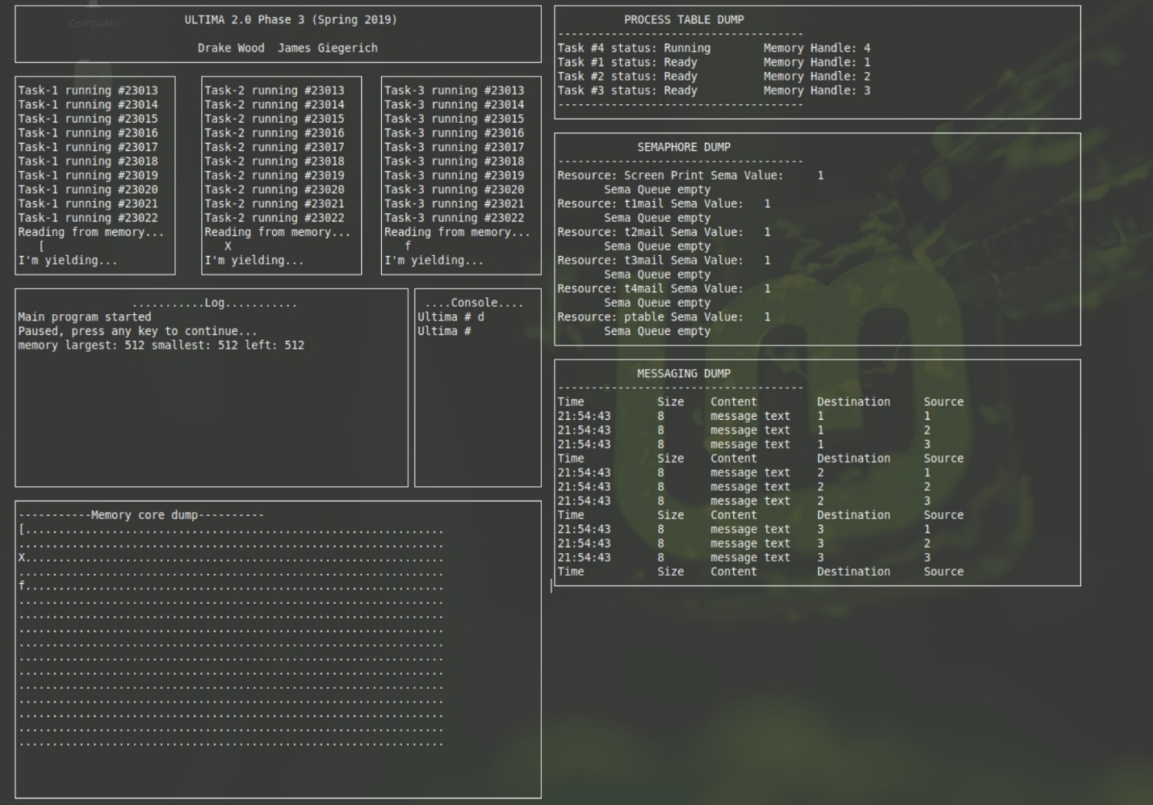
Here we are displaying the write and read, each of the tasks writes a random bit to their memory at the beginning of their cycle and reads it into their window at the end. We can see in the Memory core dump that the memory contains the same thing that was read back. In the log window the largest, smallest and memory left are displayed, 4 128bit blocks are taken by the threads and 1 512 bit block remains.
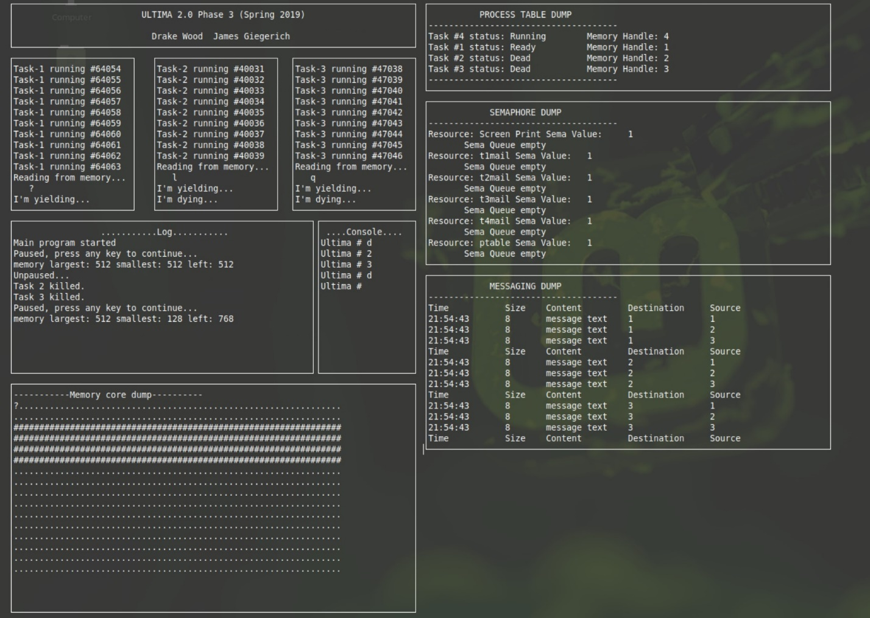
This output shows what happens when a task is killed, and its memory is freed. Task 1 still has its memory while 2 and 3 both have been cleared. 512 is still the largest block available but now the smallest is 128 and there is 768 total free.
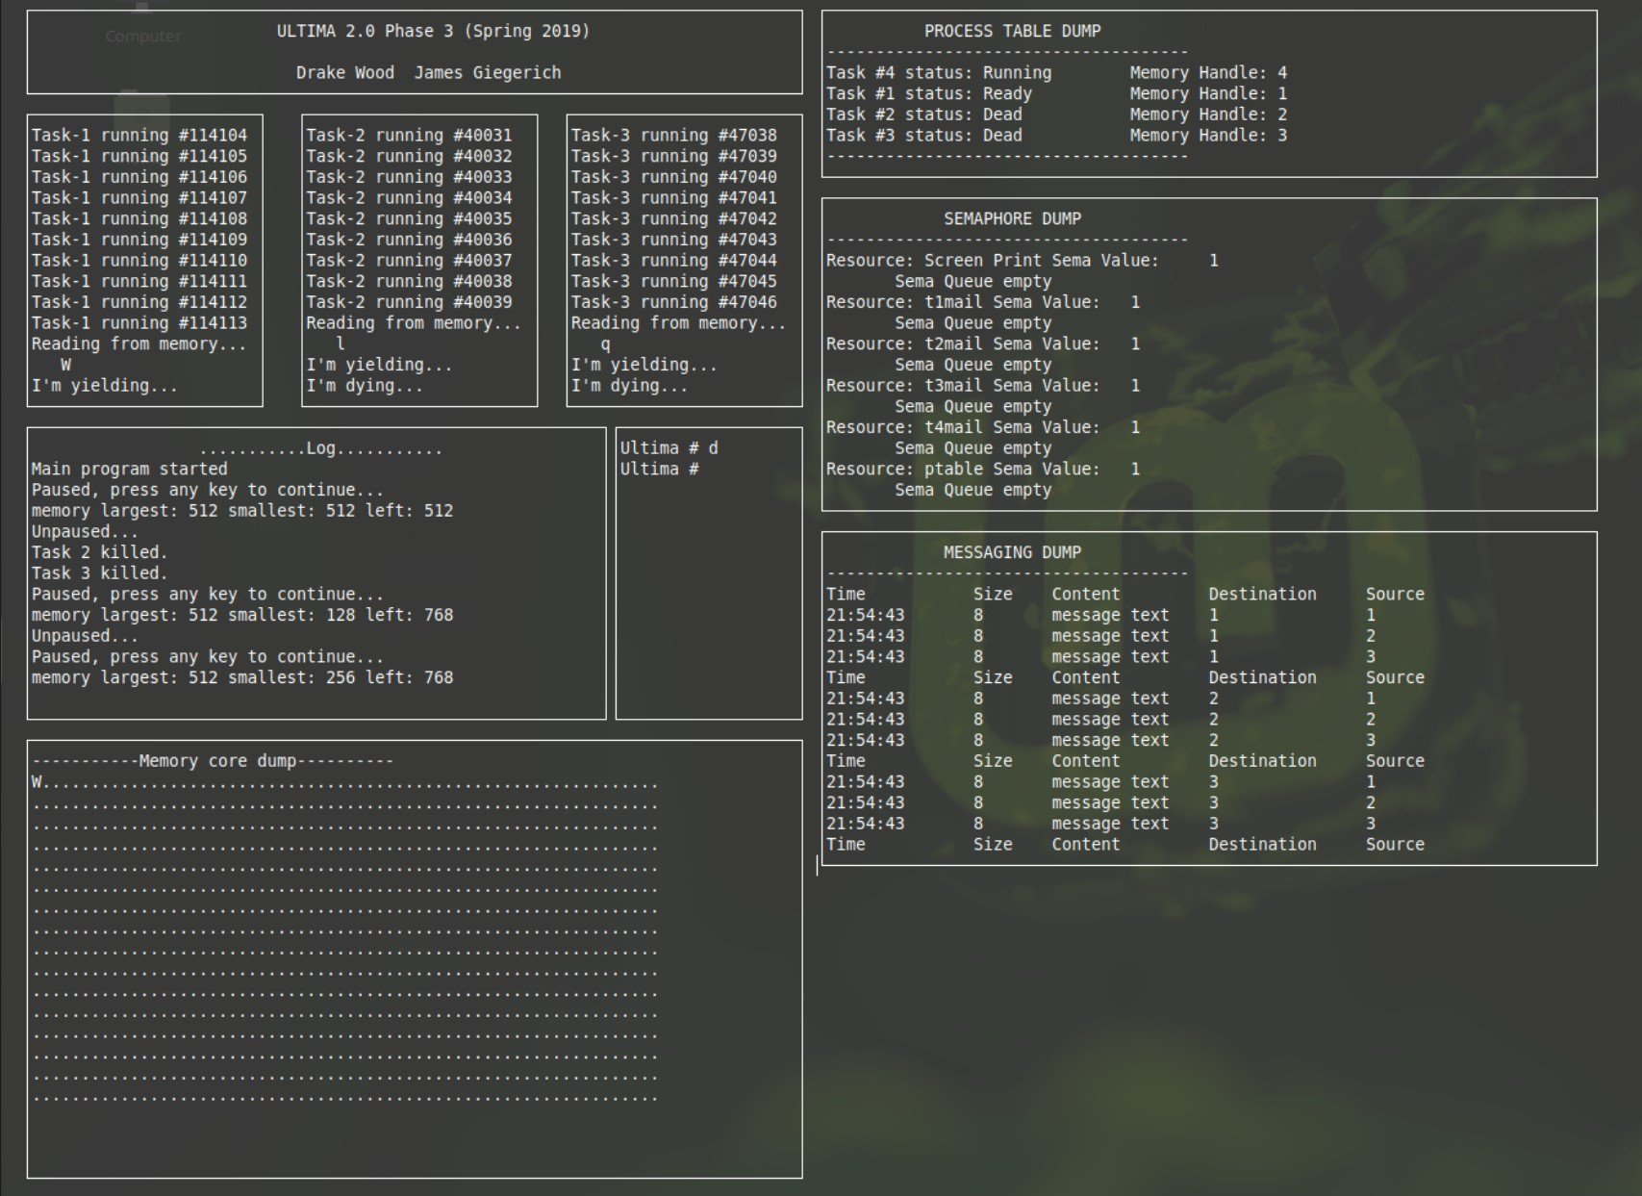
This is directly after the last output and coalesce has been called. The memory has been reset back to dots for task 2 and 3. 512 is still the largest memory block because task 4, the UI thread is dividing 2 holes, the 512 an the smallest 256 with a total of 768 remaining.
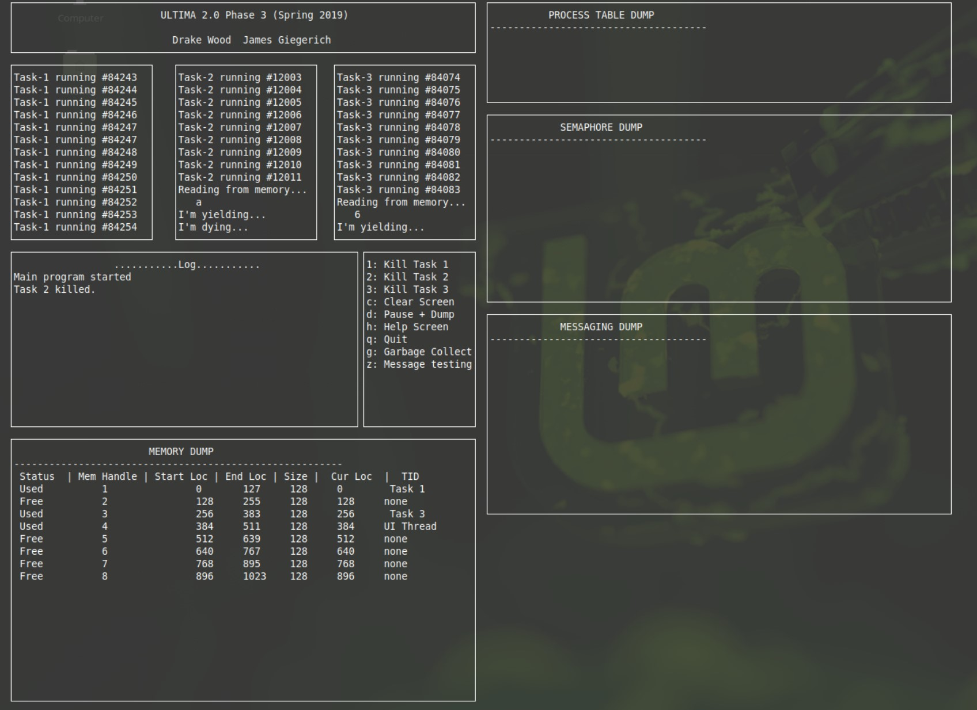
This output has the memory dump that displays each blocks status, we can see that task 2 has been killed and its memory was freed and is a hole between task 1 and 3.
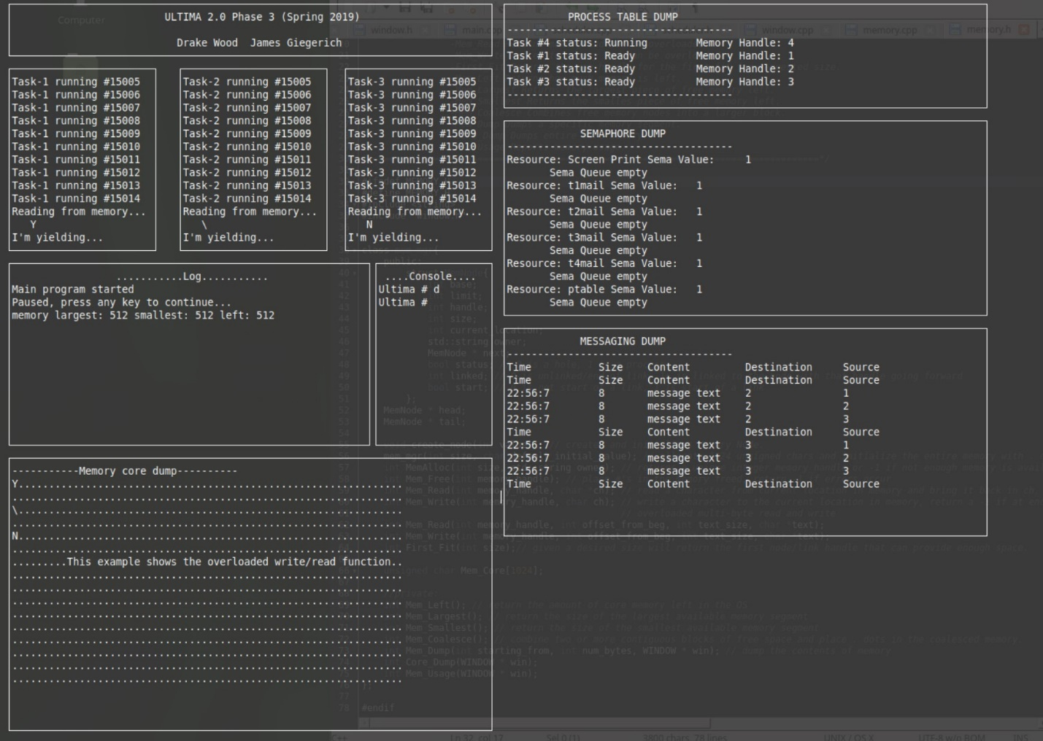
This last output shows the overloaded write with a 9-offset coming from the UI thread with handle 4. We were unable to successfully implement the overloaded read function so there is no output for that function.

